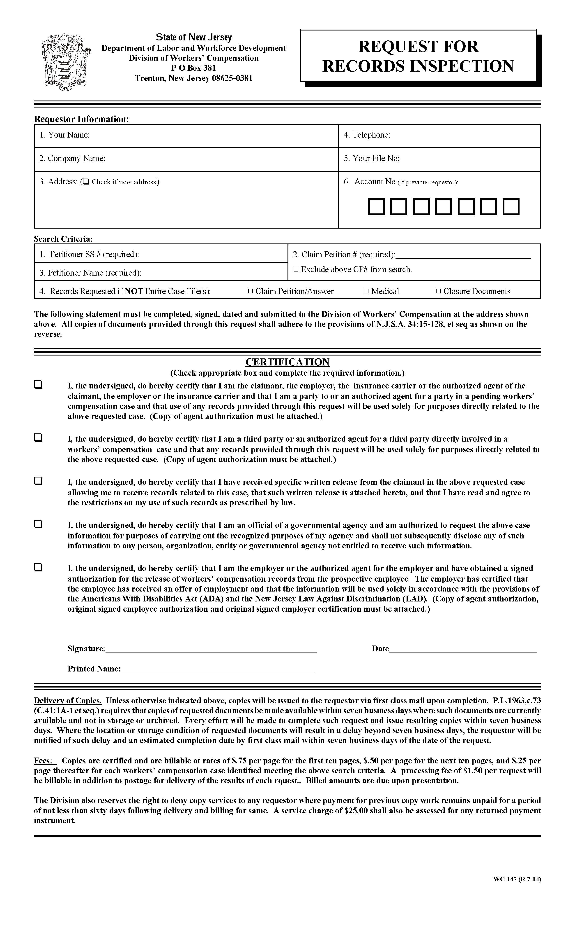

Order No. 01-20256 - 001
Marilyn A. Gallagher

2869 Jolly Rd
Okemos, Michigan 48864
X
01-20256 - 001

(877) 886-5090
Benjamin W. Winberg

Axiom Requisition Copy Service
Benjamin W. Winberg

Benjamin W. Winberg

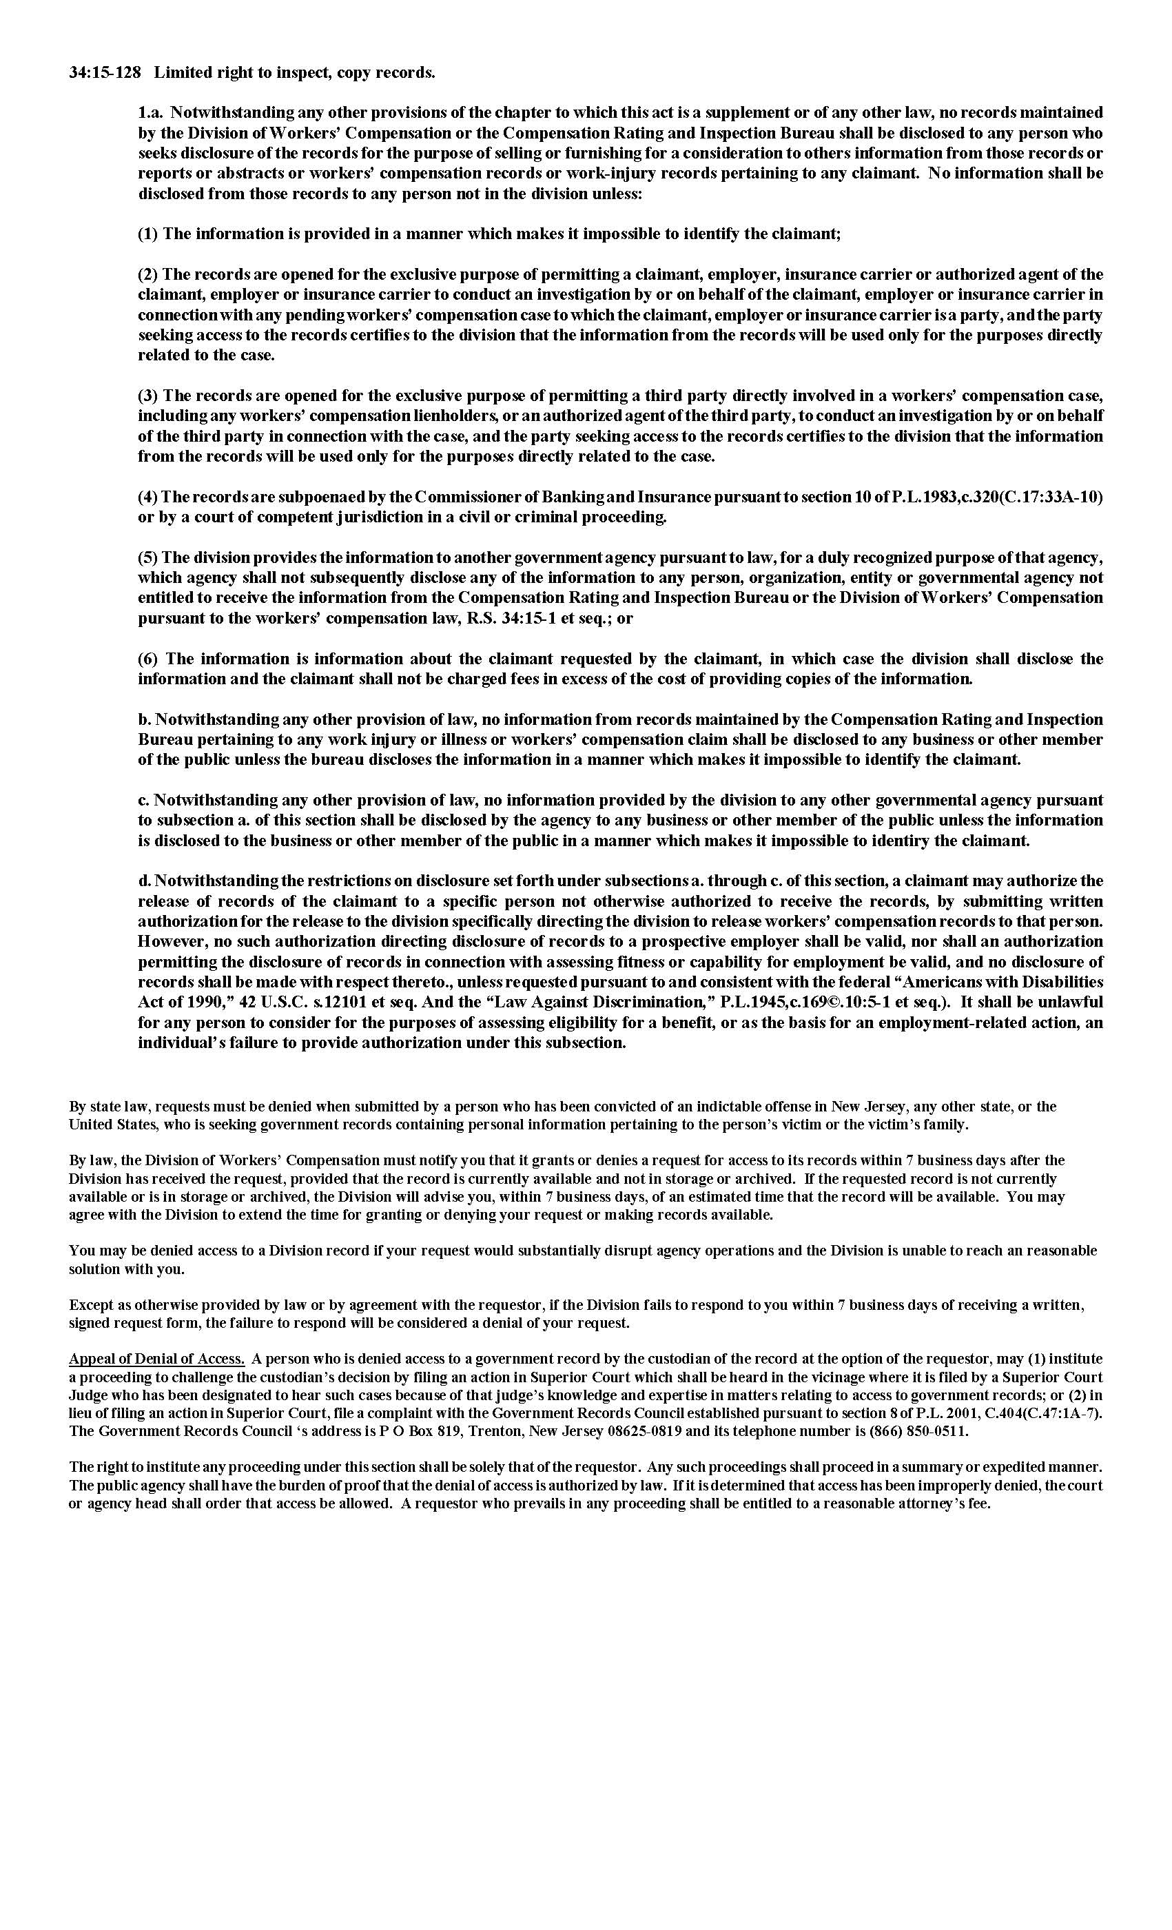
Order No. 01-20256 - 001

